1 There was a full moon on 15 October. The last quarter was on 22 October. The new moon was on 30 October. On 2 November the first quarter was showing. What will the Moon look like on 13 November? (Circle the correct alternative.)
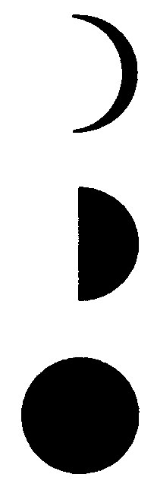
A

B

C

2 You know that the two main reasons for tides are:
• the pull of the Moon on the Earth’s watery surface
• the pull of the Sun on the Earth.
You also know the period in which the Moon revolves around the Earth.
a Use diagrams to explain how tides occur.
b Why are there usually two low and two high tides every day?
c Explain why the tides are not exactly 12 hours apart.
d Explain why we get spring tides and neap tides.

3 Explain why the appearance of the Moon changes each month. The following diagram might help you.
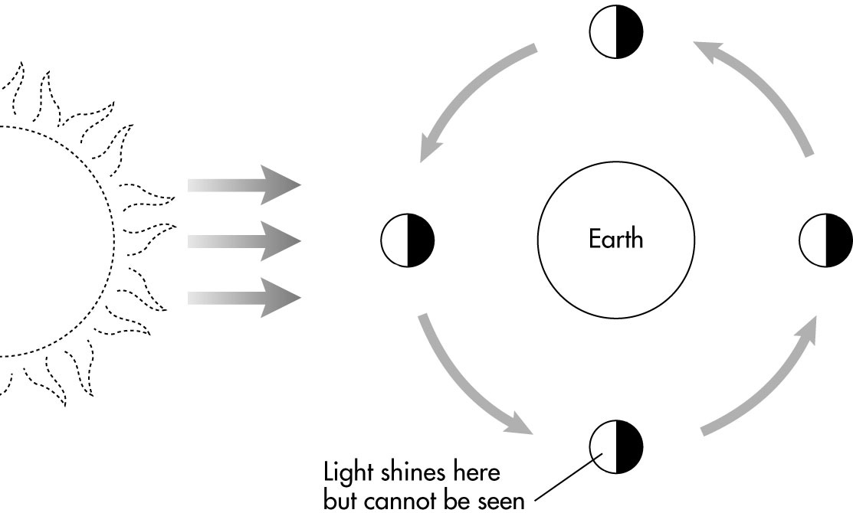

b Copy the diagram below into your workbook and label the following:
i new moon
ii full moon
iii first quarter
iv last quarter.
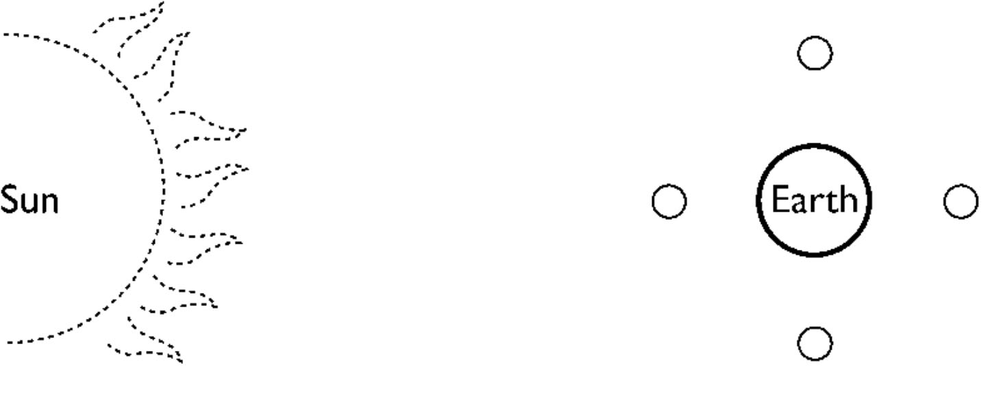

4 a Explain why we do not see an eclipse of the Moon every month.
b Draw a diagram showing the positions of the Sun, Earth, and Moon when we experience a lunar eclipse.

